Electromechanical Energy Conversion-2 (8034103-3)

Mini Project
Soft Starting for Induction motor Starting Current

Prepared by:
- Name: Turki Abdulrahman Alzahrani , ID:44451275
- Name: Majed Zuhair Gandaih , ID:44459799
- Name: Abdullah Saleh Al-Ahmari, ID: 44400543
- Name: Osama Mazen Zawawi ID:44453706

1.Inroduction

The three-phase induction motor is the workhorse of modern industry due to its simple construction, robustness, and low maintenance. However, a significant operational challenge is its high starting current. When an induction motor is started by connecting it directly to the full voltage of the power supply (Direct-On-Line starting), it can draw an inrush current that is 5 to 8 times its full-load current.
This high starting current has several detrimental effects, including:
- Voltage Dips: Causes a significant drop in line voltage, which can affect other equipment connected to the same power source, leading to flickering lights and malfunctions.
- Mechanical Stress: Subjects the motor's shaft, coupling, and driven load to high starting torque transients, leading to increased wear and tear.
- Electrical Stress: Generates excessive heat in the stator windings, which can degrade insulation and shorten the motor's operational lifespan.
- High Demand Charges: In large installations, the high inrush current can lead to utility demand charges and require oversized protective devices.

To mitigate these issues, soft starting methods are employed. Among the most effective and versatile methods is the use of a Variable Frequency Drive (VFD). This project focuses on implementing and analyzing the VFD method to achieve a smooth and controlled start for a three-phase induction motor, thereby significantly reducing the starting current and its associated negative impacts.

2. Objective

The primary objective of this mini-project is to design, implement, and analyze a soft-starting system for a three-phase induction motor using a Variable Frequency Drive (VFD). The specific aims are:
- To understand the fundamental principles of induction motor operation and the cause of high starting current.
- To investigate the working principle of a Variable Frequency Drive (VFD) and its application as a soft starter.
- To design and set up a practical circuit where a VFD controls the starting sequence of an induction motor.
- To measure and compare the starting current and torque characteristics of the motor with and without the VFD soft-start system.
- To analyze the performance of the VFD method in terms of starting current reduction, smoothness of acceleration, and overall system efficiency.
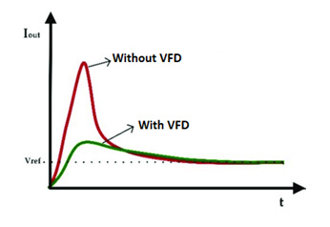

3.Equipment list and set-up:
The following components are required to construct and test the soft-start system:
- Three-Phase Programmable Voltage Source: Simulates the AC grid supply (adjusted to 615V).

- Universal Bridge (Diode Configuration): Acts as the Rectifier to convert AC to DC.

- Series Resistor: Limits current and represent source resistance.

- Capacitor (DC Link): Acts as a Low Pass Filter to smooth the DC bus voltage and provides a soft-start effect.

- Universal Bridge (IGBT): Acts as the Inverter to chop DC voltage into variable frequency AC.

- Asynchronous Machine SI Units (Squirrel Cage): The 5HP 460V 1750RP Induction Motor model used as the load.

- Knob: Allows manual adjustment of reference speed during simulation.

- Rounding Function: Rounds the analog knob signal to the nearest integer for a clean speed command.

- Constant Block: Sets fixed system parameters.

- Gain Block: Performs mathematical scaling.

- Sine Wave Block: Generates the Reference Signal for the SPWM modulation.

- Repeating Sequence: Generates the high-frequency Triangle Carrier Wave and the other Generates the reference frequency command.

- Relational Operator: Compares the Sine and Triangle waves to generate PWM logic pulses.

- Logical Operator (NOT): Inverts signals for the lower IGBT switches to prevent short circuits.
- PowerGUI: The solver engine for the simulation (configured to Discrete mode).

- Voltage Measurement: Measures instantaneous Line-to-Line voltage.

- Bus Selector: Extracts internal signals (Speed, Torque, Current) from the motor model.

- Display Block: Shows numerical values (RPM, Volts, Amps) on the screen.

- Scope: Visualizes the waveforms of Speed, Current, and Torque over time.

- Subtract Block: Acts as the Error Detector.

- PI Controller: Corrects the error signal to ensure stable and accurate speed control.

- Integrator Block: Performs mathematical integration over time.

  - Theoretical background

This section covers the core principles behind the high starting current of induction motors and how a VFD provides an effective solution.

4.1 The Starting Current Problem in Induction Motors
At the moment of start-up, the rotor of an induction motor is stationary (standstill). The relative motion between the stator's rotating magnetic field (synchronous speed) and the stationary rotor is at its maximum. This results in the induction of a very high voltage and current in the rotor bars. According to the equivalent circuit model, the rotor's reactance is high at standstill (s=1), while its effective resistance is low. This high reactance-to-resistance ratio leads to a low power factor and a very high magnetizing current drawn from the stator, manifesting as the high inrush current.

4.2 The VFD Solution: V/f Control
A Variable Frequency Drive (VFD) mitigates this problem by controlling both the voltage and frequency supplied to the motor. The principle is based on maintaining a constant Volts-per-Hertz (V/f) ratio.

- Flux Maintenance: The torque in an AC motor is proportional to the magnetic flux. The flux (Φ) in the stator is approximately proportional to V/f. To avoid magnetic saturation at low frequencies and maintain constant flux for optimal torque production, the voltage must be reduced proportionally with the frequency.

- Soft Start Principle: The VFD starts the motor by applying a very low frequency (e.g., 2-5 Hz) and a correspondingly low voltage. Since the synchronous speed (Ns = 120f/P) is now very low, the slip at start-up is small, and the starting current is dramatically reduced to only 100-150% of the full-load current.

- Controlled Acceleration: The VFD then gradually ramps up the output frequency and voltage at a controlled rate (acceleration ramp time). This allows the motor to accelerate smoothly to its desired speed without drawing excessive current, as the slip is controlled throughout the process.

4.3 Advantages of VFD Soft Starting for Induction Motors
- Drastic Current Reduction: Limits starting current to a safe level, close to the full-load current.
- Smooth Acceleration: Eliminates mechanical shocks ("jerk") to the shaft and connected load, reducing wear.
- Controlled and Optimized Torque: Provides better control over starting torque, which can be matched to the load requirements.
- Energy Savings: At reduced speeds and loads, the VFD can lower voltage and frequency, leading to significant energy efficiency.
- Full Protection: Modern VFDs include built-in protection against overcurrent, overvoltage, undervoltage, phase loss, and overtemperature.

  - Circuit Procedure:
5.1 Safety and Initial Checks
- Ensure all power supplies (AC Mains, DC Supply) are switched OFF.
- Verify that all wiring connections are correct, secure, and in accordance with the circuit diagram.
- Set the Rheostat for the field winding to its maximum resistance position.
- Configure the VFD according to the motor's nameplate data (Rated Voltage, Current, Frequency, Power).
5.2 VFD Parameter Settings
Program the following key parameters into the VFD (exact parameter names may vary by manufacturer):
- Acceleration Ramp Time (Ramp-up Time): Set to a high value (e.g., 10-20 seconds) for a soft start.
- Starting Frequency: Set the initial output frequency (e.g., 2 Hz).
- Maximum Output Frequency: Set to the motor's rated frequency (e.g., 50 Hz or 60 Hz).
- V/f Curve: Select the appropriate curve (usually linear for constant torque loads).
- Motor Control Mode: Select V/f control mode.
5.3 Direct-On-Line (DOL) Starting Test (For Comparison)
- Disconnect the VFD. Wire the synchronous machine directly to the main AC supply through a contactor.
- Set up the oscilloscope to capture the current waveform on one channel.
- Ensure the field winding is excited with the appropriate DC current.
- Briefly energize the contactor to start the motor and immediately capture the current transient on the oscilloscope.
- Switch OFF the power and note the peak value of the inrush current. This is your baseline for comparison.
5.4 VFD Soft Starting Test
- Reconnect the circuit through the VFD as described in the set-up.
- Double-check all VFD settings.
- Apply DC excitation to the field winding.
- Initiate the start command from the VFD keypad.
- Observe the motor's acceleration. It should be smooth and quiet.
- Simultaneously, use the oscilloscope to capture the stator current during the entire ramp-up period.
- Note the maximum current value observed.
5.5 Data Recording and Analysis
- Compare the current waveform and peak value from the VFD start with the DOL start.
- Measure the time taken to reach full speed in both cases.
- (Optional) Apply a mechanical load using the prime mover and repeat the VFD start to observe performance under load.
- Document all observations, waveforms, and measured values.

- Results:
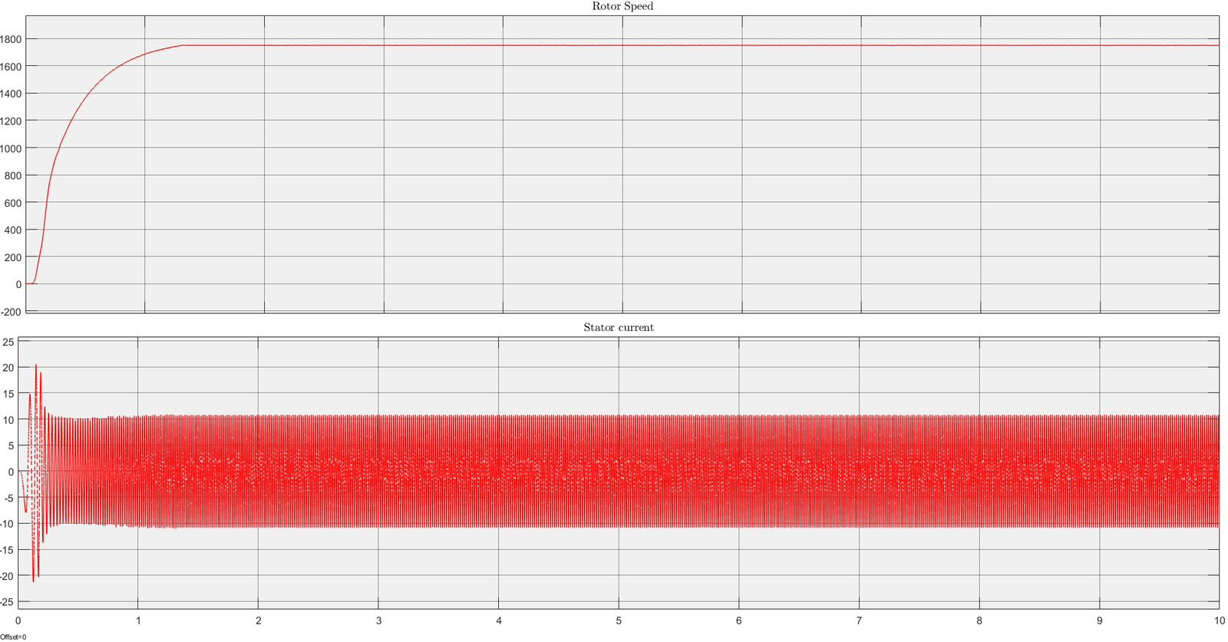
  - speed vs current with vfd

Rotor Speed (Top Plot)
The rotor speed increases smoothly and reaches its final value without any overshoot. The startup is gradual and controlled, showing that the updated VFD model provides a stable acceleration. The small oscillation at the beginning is part of the normal transient response

Stator Current (Bottom Plot)
The stator current starts at a low and controlled level instead of showing a large inrush spike. This smooth behavior is a result of the VFD soft-start method, which gradually increases voltage and frequency. The current quickly settles into a steady waveform, confirming that the starting current has been successfully reduced.

  - speed vs current without vfd
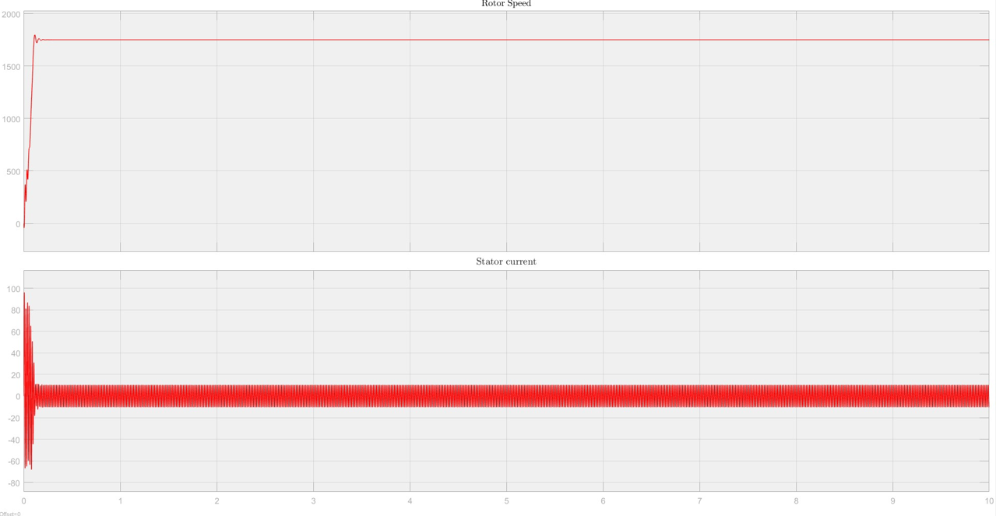

Rotor Speed (Top Plot)
The rotor speed rises very quickly with a noticeable abrupt jump at the beginning. The machine reaches its final speed almost instantly, which shows the aggressive acceleration typical of direct-on-line (DOL) starting. Small oscillations appear due to the sudden high torque applied at startup.

Stator Current (Bottom Plot)
The stator current shows a very large inrush spike at the moment of startup, reaching a high peak before settling into a steady waveform. This high current peak is characteristic of DOL starting and indicates strong electrical stress on the machine windings.

- Conclusion
In this project, a soft-starting method for a Induction motor was implemented using VFD control in a MATLAB/Simulink environment. The results showed that the V/f approach significantly reduced the inrush current and provided a smooth acceleration compared to direct-on-line starting. Rotor speed increased gradually and steadily with the V/f method, while the DOL start produced a sharp jump and high electrical stress. Overall, the simulation demonstrated the effectiveness of V/f soft starting in improving system stability and protecting the machine. This confirms the importance of controlled startup techniques for Asynchronous machines.

